March 2013

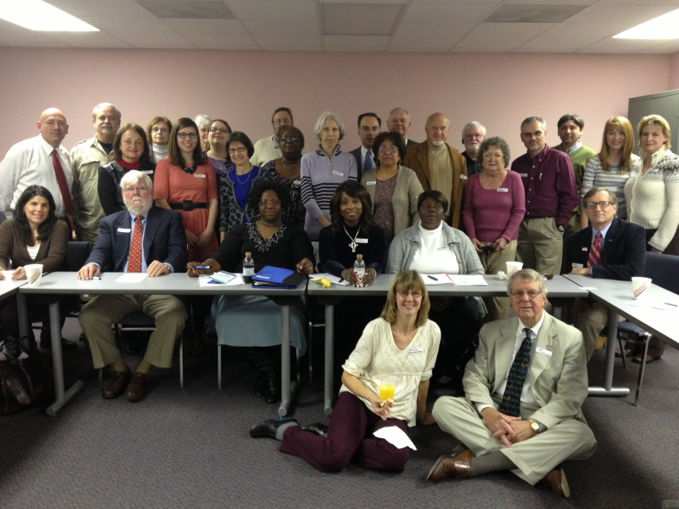
March represented our most active month to date. With all hands rowing towards our March 9th Community Conference there were substantial email traffic, phone calls and letters. While the level of activity may have been about right for many, it was exhausting for the Steering Committee (Ball, Keely and Perez-Jorge).

INSIDE – A nucleus of activists is percolating in the organization. The email traffic initially was almost exclusively through our Chapter President, Dave Keely. He does an excellent job both coordinating activity and broadcasting announcements. The HFA-SC info-email recipient list is now up to 127 individuals. Also, we are beginning to see more internal emails, initially from our Progressive Network member (Bursey) and Organized Labor (Dewitt), and others (Brett; Shrader).

Once the Steering Committee holds the monthly phone call, the next Healthcare For All –South Carolina meeting date will be posted. At this point the Low Country needs to step up and take over after the solid effort made by the Midlands Ambassador in Columbia. While a Charleston Ambassador has not yet been identified, the significant activity on March 8th should be sufficient to cobble together a committee to host the next HFA meeting.

OUTSIDE – With Dr. Art Sutherland’s visit from the National Board approaching, the Steering Committee pushed in late February and early March to ensure his visit would be productive. We invited Dr. Sutherland to come to Charleston prior to the Conference in order to boost interest in the Charleston area. He arrived on Thursday March 7th ready for a full agenda the following day.

The Charleston County Medical Society (CCMS) was initially courteous when approached. Ball met with the Society President who was cool but respectful. At the conclusion of the meeting, he and the office manager agreed to host a breakfast meeting for our visitor.

By the time Ball returned to his office, an email was waiting regretting that, since the CCMS President would be unavailable to attend, it looked like the meeting could not be arranged. It would take a petition and request from a CCMS member to make it happen. The local chapter of the SCMA expressed “concern” about hosting an advocate without having a “balanced view”.

Before becoming a registered nurse Ball had been a salesman. He was told many years ago that until the salesman got told “No” he was just an order taker. We called some of our PNHP friends and the Society reluctantly agreed to host the breakfast. The day of the event the initial chilly demeanor of the CCMS office manager gradually began to warm. By the end of the event she was beaming and was proud of scheduling the event and supplying the gourmet doughnuts. The early morning breakfast drew about a dozen participants. A few were long time believers, several were open to fixing our dysfunctional healthcare financing system, and a few were highly skeptical. The discussion was respectful and stimulating. Not all heads bobbed in the same direction but folks were honest and thoughtful.

Dr. Jeb Hallett is a vascular surgeon who practices at Roper Hospital, the main competitor to the state-owned Medical University of SC. The two major hospitals are actually situated right across the street from one another. Dr. Hallett had penned a well written op-ed in the Post and Courier advocating Medicaid expansion to refute the position of SC Governor and GOP-darling Nikki Haley. Hallett presides over a 200-member set of physician practices that treat patients at Roper, and he is in love with the French health care system. His response after our meeting was to email the business directors and key doctors from the 200 provider organization.

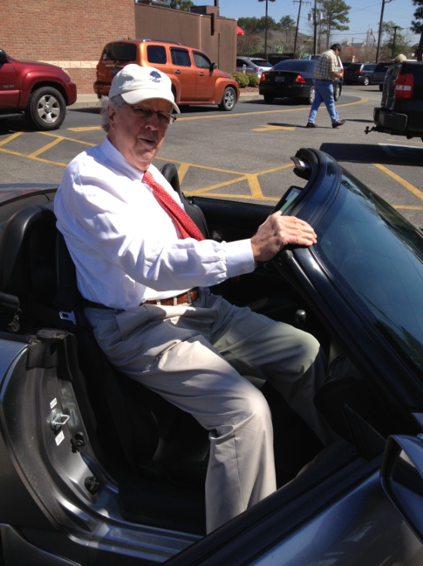
Of the eight that met in the Roper executive conference room, half were physicians and half business directors. The atmosphere was reserved but supportive. By the end of the hour it was clear that all were supportive to varying degrees. Two business directors (Bowling and Handy) seemed both supportive and motivated. When Ball had a subsequent meeting with Handy, she agreed to commit to the cause. Hopefully she will be a part of organizing the first Charleston event.

Throughout the day the lanky Dr. Sutherland had to climb into and out of Ball’s small sports car. In order to get in, the car’s top was removed and then replaced due to cool driving weather. This procedure was performed at all 5 events in a day that lasted 14 hours! After lunch, Art made a PowerPoint presentation to MUSC Residents. We expected young, idealized doctors with a lifetime of dealing with billing in their future to be receptive to our message. On the contrary, we found them bored, closed-minded, and borderline hostile.

Two showings of The Healthcare Movie were given, one at the downtown library and an evening performance at a small community center. Despite an electronic blast to 2200 Facebook users and extensive flyers both performances were poorly attended. The afternoon show at the library brought a dozen and the evening show half that. Attendees were local activists already supportive to our cause.

The main event (March 9th) was held at the South Carolina Nurses Association main office in downtown Columbia (our State Capital), about a block from SC Governor Haley’s mansion. Attended by 35-40 people, it was a great mix of healthcare providers, progressive activists, faith-based folks, organized labor, and other community-based organizations.
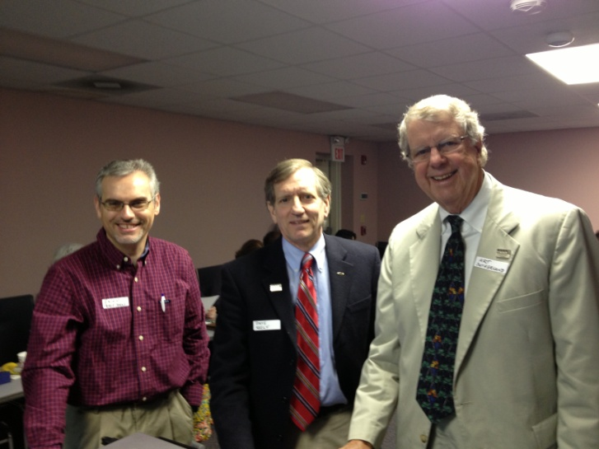
Good discussion ensued, notably involving a financial analyst VP from the South Carolina Hospital Association (which strongly supports Medicaid expansion in SC under the Affordable Care Act), an operator of a free clinic, those involved with PNHP for some time, and politically-savvy operatives from organized labor and social justice groups. Dr. Sutherland gave a lengthy presentation with some rather dense material. This provided a great deal of information, especially for those unfamiliar with Single Payer, but might have caused some attentions to drift a tad. Brett Bursey, our political strategist, finished the meeting with practical ways we could strongly advocate to expand Medicaid.
L-to-R: Drs. Perez-Jorge, Keely, and Sutherland

AMBASSADORS – This is where our organization moves past the founders (Keely & Ball) to a Steering Committee of the President, National Liaison, and four Regional Ambassadors. After 6 months in existence we have our first Ambassador (Midlands) and see that the next needs to come from the Charleston area (Lowcountry Region). By the fall of this year, we would hope to have Ambassadors in place for the Upstate Region and the Pee Dee Region.

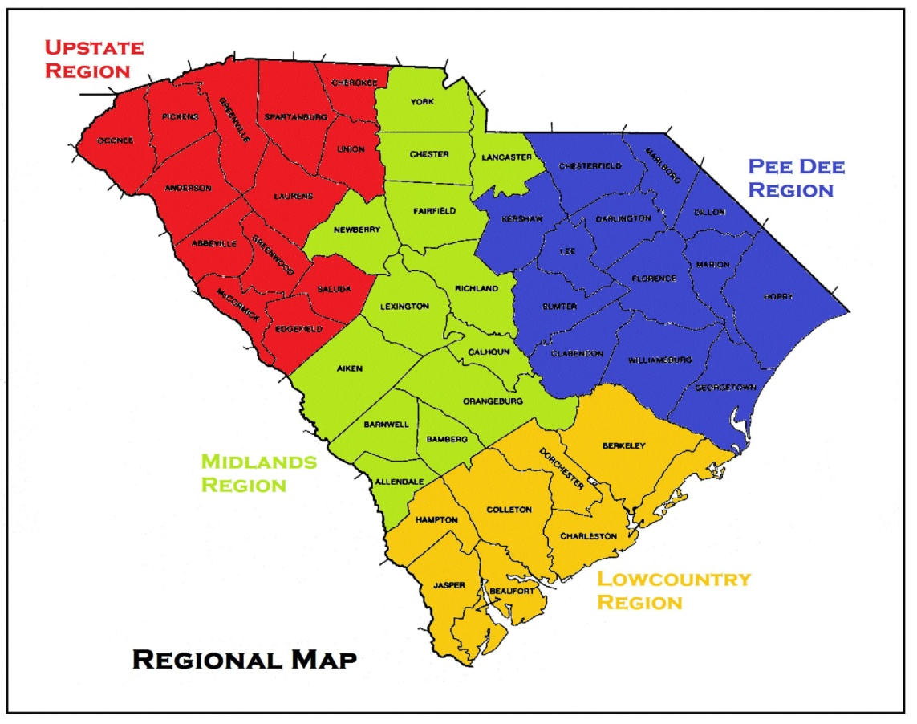
HEALTHCARE FOR ALL – SOUTH CAROLINA

